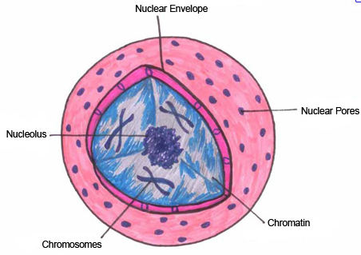 | Nucleus
‘Brains of the cell’; houses DNA
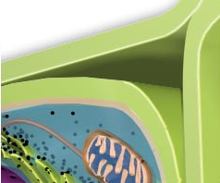 | Cell Wall
Shapes and supports plant cells
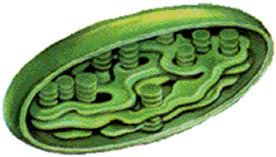 | Chloroplasts
Food for plant cell is made here
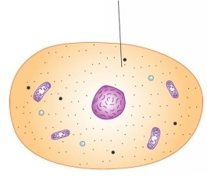 | Cytoplasm
Jelly-like stuff inside of the cell
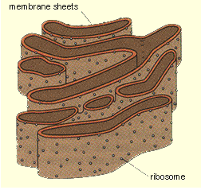 | Endoplasmic Reticulum
Surface for chemical activity
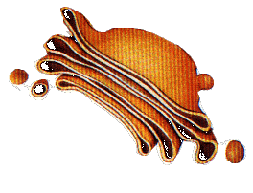 | Golgi Apparatus
Stores and releases chemicals
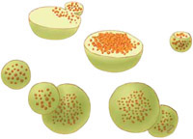 | Lysosome
Digestion center
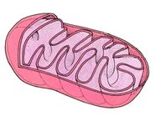 | Mitochondria
‘Powerhouse’; makes ATP
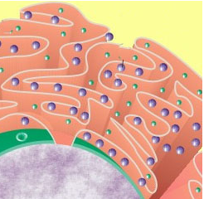 | Ribosomes
Where proteins are made
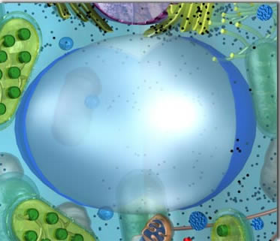 | Vacuole
Contains water & dissolved minerals

